AI-Powered Smart Shopping Assistant
P1A1

Problem statement:
Shoppers often struggle with finding the best deals, choosing the right products, and staying within budget. Many online platforms offer discounts, but comparing them manually is time-consuming and inefficient. Additionally, some customers need personalized recommendations based on their preferences, previous purchases, and shopping habits.

The main idea in solving this problem is to create a filter for the customer's preferences through which he can determine the limit he is allowed to spend when purchasing necessities by integrating artificial intelligence into the application or purchase page.

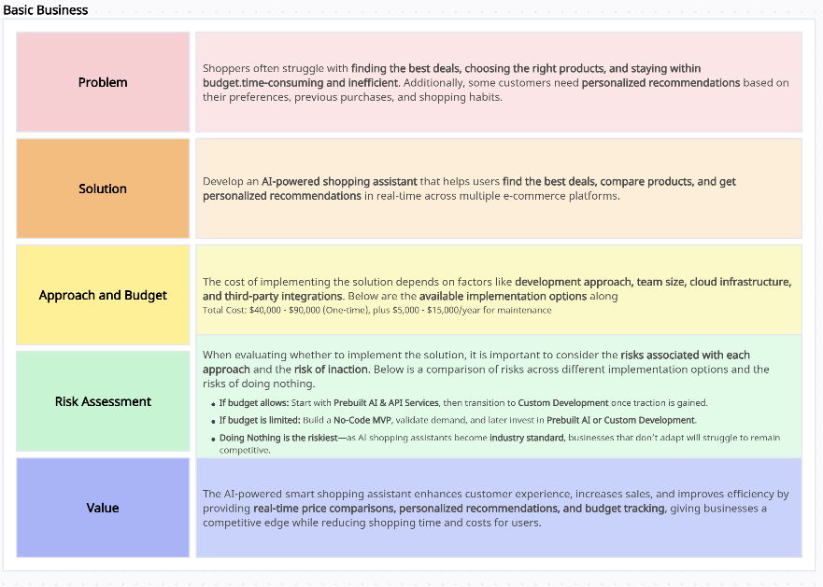
Business case:

Scope:

The scope of the AI-powered smart shopping assistant includes developing a platform that integrates with multiple e-commerce websites to offer real-time price comparisons, personalized product recommendations, and budget tracking. It will support features like deal alerts, voice assistant compatibility, and sustainability ratings. The solution will be available as a mobile app and web platform, providing users with a seamless and efficient shopping experience while helping businesses increase customer retention and sales.

Goals:
The goals of the AI-powered smart shopping assistant are:
- Enhance User Experience: Provide a seamless, personalized shopping experience through real-time price comparisons, recommendations, and budget management.
- Increase Customer Engagement: Retain users by offering timely deal alerts, product suggestions, and a user-friendly interface.
- Boost Sales for Retailers: Help businesses drive more sales by connecting customers with the best deals and relevant products.
- Reduce Shopping Time and Effort: Enable shoppers to find the best offers and make informed decisions faster, reducing the time spent searching.
- Promote Sustainability: Offer eco-friendly product recommendations, promoting responsible shopping habits.
- Enable Data Insights: Collect data on customer preferences and behavior to improve recommendations and marketing strategies.

